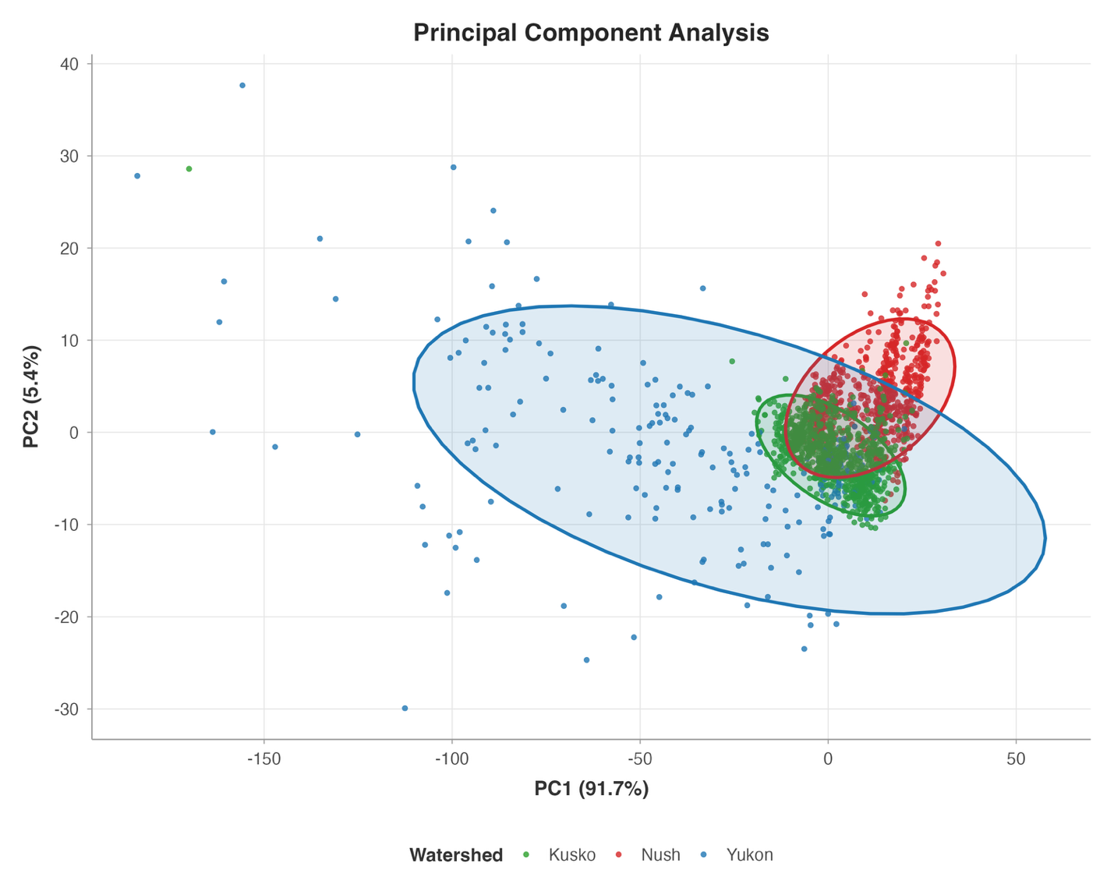
Supp Figure 1: PCA of GAM smoothed Sr8786 timeseries data from Chinook salmon otoliths in Western Alaska with all Middle and Upper Yukon individuals removed. Each point here is a single individual timeseries. Yukon individuals within the Coastal Western Alaska genetic reporting group (CWAK) are blue, Kuskokwim is red, and Nushagak is green. Data show a similar pattern to the PCA with all individuals (including non CWAK Yukon samples) , but with less points in the extreme range of both PC1 and PC2. These results illustrate the increased spread in the principal component data as a result of unique timeseries shapes for many non-CWAK individuals compared to those in the lower watershed.

